RECURSION QUESTIONS

Table of Contents
LEVEL 1: Easy 2
1. Find factorial of number using recursion. 2
2. Find the nth term of Fibonacci series. 0,1,1,2,3,5,8… 2
3. Recursive function to reverse the string. 2
4. Print n to 1 numbers in reverse order. 2
5. Print 1 to n numbers using recursion. 2
6. Write recursive function to calculate sum of ranges of numbers 2
7. Recursive function to count occurrences of given character in string 2
8. Write a recursive function to find sum of all digits in a number. 2
9. Find maximum number in the list of integers. 2
10. Recursive function to find power of number. 2
11. Recursive function to check if string is palindrome. 2
12. Find gcd of two numbers. 2
13. Print a special series 2
LEVEL 2: Moderate 3
1. Print star pattern. 3
2. Print Pattern 3
3. Find ways to go to party. 3
4. Recursive function to merge two sorted lists. 3
5. Print all subsets of array. 3
6. Count of binary strings 3
7. Print all n length binary strings not having adjacent 1’s. 3
8. Is subsequence? 3
9. Print all paths in 2D grid 3
10. Print all paths in 2D grid with diagonal move too 3
LEVEL 3: Difficult 4
LEVEL 4: Expert 5
SOLUTIONS 6
LEVEL 1: 6
LEVEL 2: 12

LEVEL 1: Easy

Find factorial of number using recursion.

Find the nth term of Fibonacci series. 0,1,1,2,3,5,8…

Recursive function to reverse the string.

Print n to 1 numbers in reverse order.

Print 1 to n numbers using recursion.

Write recursive function to calculate sum of ranges of numbers
Eg: sum of all numbers from a to b (a and b inclusive)

Recursive function to count occurrences of given character in string

Write a recursive function to find sum of all digits in a number.
Eg. For number 101249, sum of digits is 17

Find maximum number in the list of integers.

Recursive function to find power of number.
Eg. Find num power of x, in most effective way

Recursive function to check if string is palindrome.

Find gcd of two numbers.

Print a special series
You are given a series defined by T_{n}= (T_{n-2})² – (T_{n-1}) .Here 1st and 2nd values are 0,1. Print the first N values. GFG question

LEVEL 2: Moderate

Print star pattern.
Eg. For n = 4 pattern is **** *** ** *

Print Pattern
Print a sequence of numbers starting with n, without using a loop. Replace n with n - 5, n−5... until n≤0. Then, replace n with n+5, n + 5, n+5 until n regains its initial value.
GFG question

Find ways to go to party.
There are N persons who want to go to party. There is constraint that any person can either go alone or go in a pair. Calculate number of ways in which n persons can go to the party. Eg for n=3 , persons A,B,C can go as [A,B,C] , [A,(B,C)] , [(A,B),C] , [(A,C),B] = total 4 ways

Recursive function to merge two sorted lists.

Print all subsets of array.

Count of binary strings
Count number of ways to make a binary string of length n, where there is no adjacent 1.

Print all n length binary strings not having adjacent 1’s.

Is subsequence?
Given two strings s and t, return true if s is a subsequence of t, or false otherwise. A subsequence of a string is a new string that is formed from the original string by deleting some (can be none) of the characters without disturbing the relative positions of the remaining characters. (i.e., "ace" is a subsequence of "abcde" while "aec" is not).

Print all paths in 2D grid
You are given a 2D grid (m × n), you are at the top left point and you need to reach bottom right point. You can only go right or down. Count all possible ways and also print all the paths.

Print all paths in 2D grid with diagonal move too
You are given a 2D grid (m × n), you are at the top left point and you need to reach bottom right point. You can only go right or down and diagonally down too. Print all the paths.

LEVEL 3: Difficult

LEVEL 4: Expert

SOLUTIONS

LEVEL 1:

- Factorial of number
Recursion breaks a problem into a smaller version of itself until it hits a base case (n==1) that returns directly without recursing further. Each call then does its own self work by combining its input with the result of the subproblem — so fact(3) waits for fact(2), which waits for fact(1), then the answers multiply back up: 1 → 2*1=2 → 3*2=6.
def fact(n):
if n==1: #base case
return 1
sub = fact(n-1) #recursive subproblem
return n*sub #self work

print(fact(3))

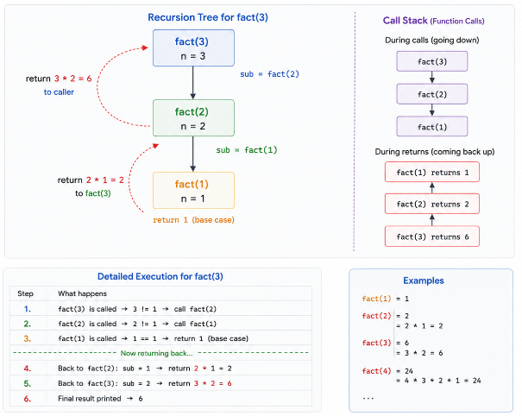
This is how recursion executes.

Time = O(N)
Space Complexity = O(N) [ due to stack used internally ]
- Fibonacci Series
def fib(n):
if(n<=1): #base case
return n
sub1 = fib(n-1) #recursive subproblem
sub2 = fib(n-2)
return sub1+sub2 #self work

print(fib(3))

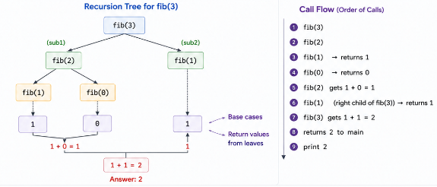

- Reverse strings

def rev(i,j,s):
if i>=j:
return ''.join(s)
s[i],s[j] = s[j],s[i]
return rev(i+1,j-1,s)

s=list("Palash")
print(rev(0,len(s)-1,s))

- Print n to 1

def print_nums_desc(n):
if(n==0): #base case
return
print(n) #self work
print_nums_desc(n-1) #recursive subproblem

print_nums_desc(5)

- Print 1 to n

def print_nums(n):
if(n==0): #base case
return
print_nums(n-1) #recursive subproblem
print(n) #self work

print_nums(5)

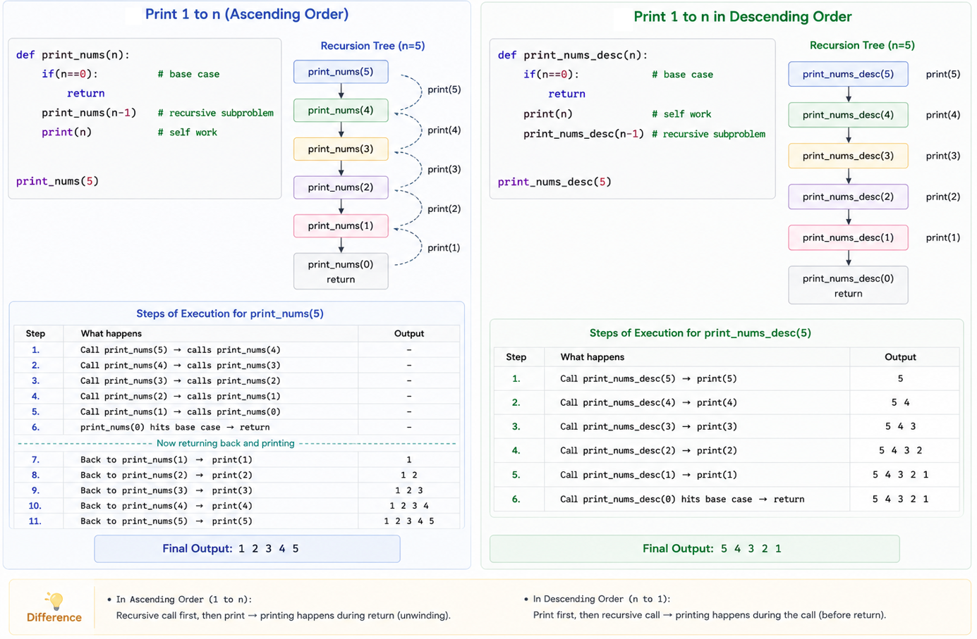

- Range sum ( sum of all numbers from start to end )

def range_sum(start,end):
if start>end : #base case
return 0
return start + range_sum(start+1,end) #self work,recursive subproblem

print(range_sum(3,5))

Method 2:
# Optimized way, lesser calls
def getSum(a,b):
if(b<a):
return 0
if b==a:
return a
return a + b + getSum(a+1, b-1)

print(getSum(2,7))

- Character occurrences in string
def count_occurances(string,char):
if len(string)==0: #base case
return 0
if string[0]==char:
return 1 + count_occurances(string[1:],char) #self work,recursive subproblem
else:
return count_occurances(string[1:],char) #self work,recursive subproblem

print(count_occurances("python application",'p'))

- Sum of digits of a number
def sum_digits(num):
if num<10: #base case
return num
return num%10 + sum_digits(num//10) #self work , recursive case

print(sum_digits(101249))

- Max number in array
def find_max(arr):
if len(arr) == 1:
return arr[0]
else:
return max(arr[0], find_max(arr[1:]))

if __name__ == '__main__':
print(find_max([1, 2, 3, 9, 5, 6, 7, 8]))

def maxNum(m,l,i):
if i==len(l):
return m
if l[i]>m:
return maxNum(l[i],l,i+1)
return maxNum(m,l,i+1)

print(maxNum(0,[21,5,2,5,9,12],0))

- Find N**X
def power(n,x):
if x==1:
return 1
else:
if(x%2):
return n*n*n*power(n,x//2)
else:
return n*n*power(n,x//2)

print(power(2,4))

- Check Palindrome
def is_palindrome(s):
if len(s) <= 1:
return True
else:
return s[0] == s[-1] and is_palindrome(s[1:-1])

print(is_palindrome('abcba'))

- GCD(a,b)

def gcd(a,b):
if(a==0): #base case
return b
sub = gcd(b%a,a) #recursive subproblem
return sub #self work

print(gcd(42,18))

Euclidean Algorithm — the core theorem:
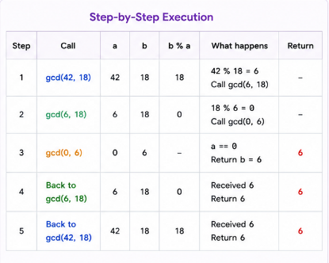
gcd(a, b) = gcd(b mod a, a), and you keep applying this until one number becomes 0 — at which point the other number is the GCD.

- GFG series
class Solution:
def gfSeries(self, N : int) -> None:
# code here
ans = [0]*N
if N>1:
ans[0]=0
if N>2:
ans[1]=1

def rec(N):
if N<=2:
return N-1
else:
temp = rec(N-2)
temp2 = temp*temp-rec(N-1)
ans[N-1] = temp2
return temp2
rec(N)

LEVEL 2:

- Print star pattern

def pattern(n,j):
if n==0:
return
if j==0:
print("\r")
pattern(n-1,n-1)
else:
print("*",end="")
pattern(n,j-1)
pattern(4,4)

#Via loop (above one, j act as for loop, and reducing n value act as while loop)
n=4
for i in range(n,0,-1):
for j in range(i):
print("*",end="")
print("\r")

#Also try printing reverse of this pattern, will need to use pattern(n,i,j)

- Print Pattern
class Solution: #learn use of global variable
def pattern(self, N):
# code here
def helper(num,N,flag):
ans.append(num)

if num<=0:
flag=1

if flag==1:
if num==N:
return
helper(num+5,N,1)
else:
helper(num-5,N,flag)

global ans
ans= [] #remember to make global arr null before running this each time
helper(N,N,0) #flag=0 means increasing, 1 means decreasing
return ans

- Ways to go to party
Let 3 persons are there A B C
F(n) denotes total number of ways to go to party
F(n) depends on 2 cases:
If A goes alone: F(n) = number of ways B,C can go to party = F(n-1)
If A goes in pair: F(n) = number of ways to make pair * (number of ways other n-2 can go to party )
= (n-1) * F(n-2)
So
F(n) = F(n-1) + (n-1)*F(n-2)

def ways_to_party(n):
if n<=1:
return 1
else:
return ways_to_party(n-1) + (n-1)*ways_to_party(n-2)

print(ways_to_party(3))

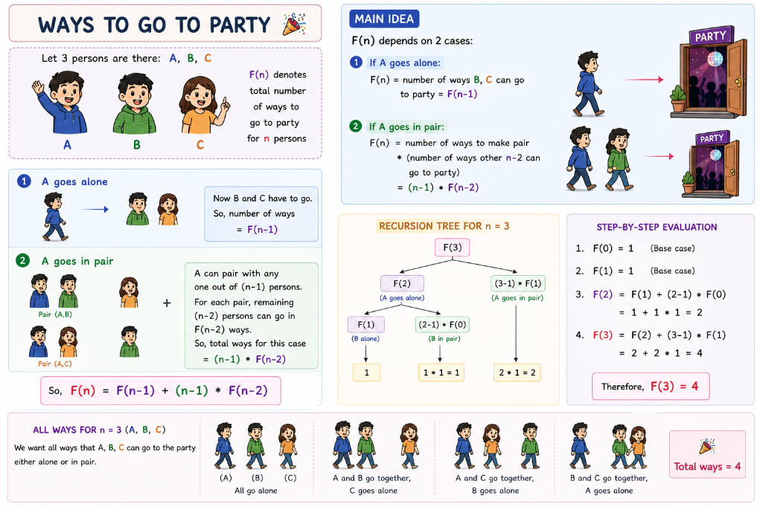

- Merge two sorted arrays
def merge_sorted(a,b,i,j):
if i==len(a):
return b[j:]
if j==len(b):
return a[i:]
if a[i]<b[j]:
return [a[i]] + merge_sorted(a,b,i+1,j)
return [b[j]] + merge_sorted(a,b,i,j+1)

a= [2,4,5,7,10]
b= [1,3,6,8,9]
print(merge_sorted(a,b,0,0))

- All subsets

def subsets(i,n,array,s): #s= output so far
if i==n:
print('['+s+']')
return
subsets(i+1,n,array,s+array[i])
subsets(i+1,n,array,s)

array=["A","B","C"]
subsets(0,len(array),array,"")
#output: [['A', 'B', 'C'], ['A', 'B'], ['A', 'C'], ['A'], ['B', 'C'], ['B'], ['C'], []]

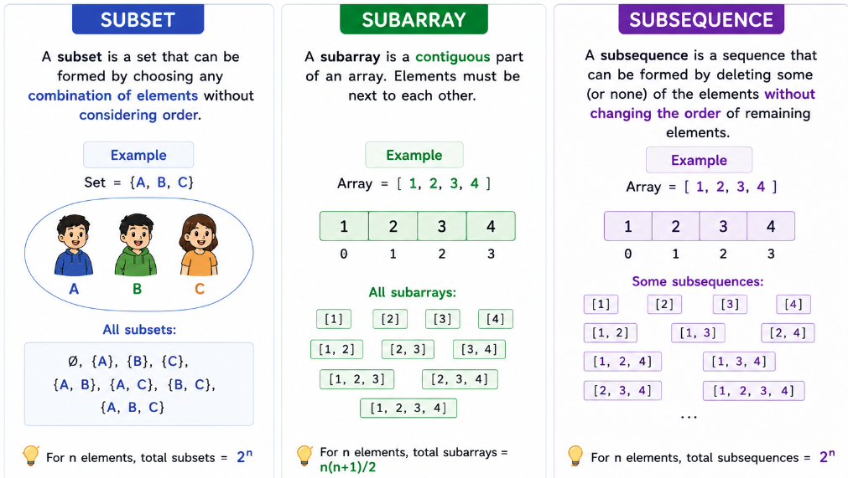

- Count of Binary strings
It forms a Fibonacci series, for n=1 count =2 (0,1) , for n=2 count = 3(00,01,10) , for n=3 count =5(000,100,010,001,101)
#count of binary strings of length n with no consecutive 1's
def count_binary_strings(n):
if n<=2:
return n+1
else:
return count_binary_strings(n-1)+count_binary_strings(n-2)

print(count_binary_strings(4))

- Print binary strings
#osf = output so far , one_flag = True if last value added was 1 else False
def binary_strings(n,i,flag,osf):
if i==n:
ans.append(osf)
return 1
if(flag==0):
return binary_strings(n,i+1,0,osf+"0") + binary_strings(n,i+1,1,osf+"1")
else:
return binary_strings(n,i+1,0,osf+"0")

global ans
ans=[]
print(binary_strings(4,0,0,"")) #this return count of strings
print(ans)
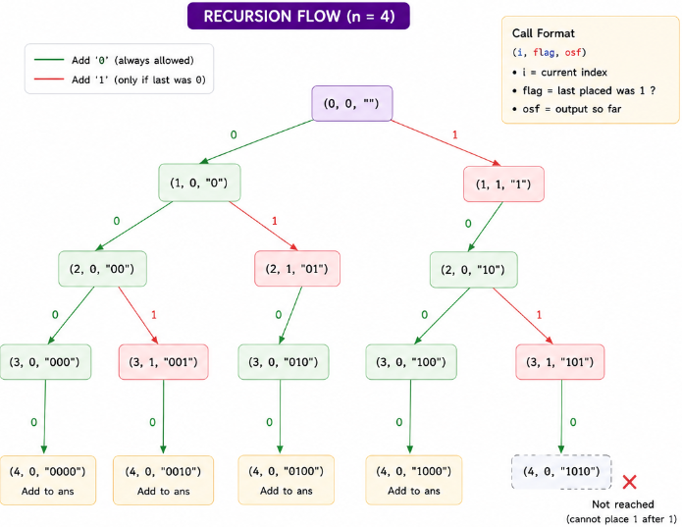

8. Is Subsequence
def isSubsequece(s,t,i,osf):
if(osf==s):
return True
if i==len(t):
return False
sub1 = isSubsequece(s,t,i+1,osf+t[i])
sub2 = isSubsequece(s,t,i+1,osf)

return sub1 or sub2

print(isSubsequece("ace", "abcde", 0, ""))

This is “take or not take approach”, you take one of the path and build osf (output so far) string. At any path, if you get desired output, return True . Else continue exploring left over paths.

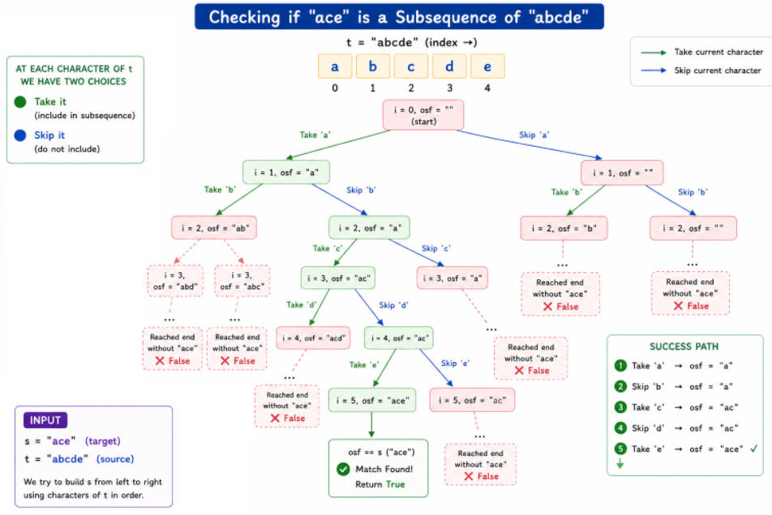

9. All Paths

def paths(i,j,m,n,s,l):
if i==m:
print(s+"D"*(l-len(s)))
return 1
elif j==n:
print(s+"R"*(l-len(s)))
return 1
else:
sub1 = paths(i+1,j,m,n,s+"R",l)
sub2 = paths(i,j+1,m,n,s+"D",l)
return sub1+sub2
n=2
m=3
print(paths(1,1,n,m,"",n-1+m-1))

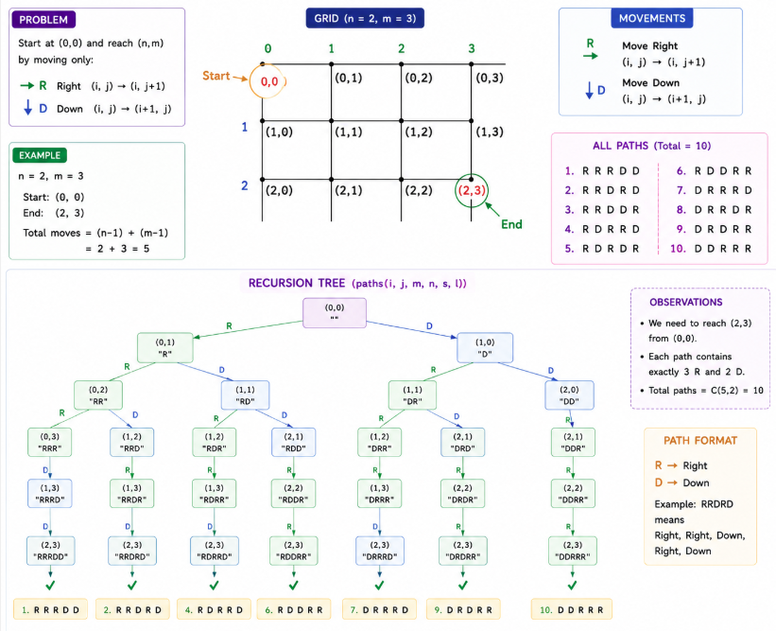

Approach: at each cell (i,j), you have two choices — move right (sub1) or move down (sub2) — and recurse on both, exploring every possible path from the start to the destination grid edge, counting all paths via sub1 + sub2.
Base cases: if you hit the last row (i==m) or last column (j==n), you've reached the edge of the grid — the only option left is to fill the remaining path with straight moves (Ds or Rs), print that completed path, and return 1 (one valid path found).
To just get count of paths:
def count_paths(m,n):
if m==1 or n==1:
return 1
return count_paths(m-1,n)+count_paths(m,n-1)

print(count_paths(2,3))

10. All paths including diagonal
#i,j = current position m,n = destination
#s = string to store the path
#R - right, B - bottom, D - diagonal
def paths(i,j,m,n,s):
if i>m or j>n:
return 0
if i==m-1 and j==n-1:
print(s)
return 1

else:
sub1 = paths(i+1,j,m,n,s+"R")
sub2 = paths(i,j+1,m,n,s+"B")
sub3 = paths(i+1,j+1,m,n,s+"D")
return sub1+sub2+sub3

m=3
n=2
print(paths(0,0,m,n,""))

Approach: at each cell (i,j), you now have three choices — move right (R), bottom (B), or diagonal (D) — and recurse on all three, exploring every possible way to reach the destination, summing up sub1+sub2+sub3 as the total path count.
Base cases: if you overshoot the grid (i>m or j>n), that path is invalid → return 0. If you land exactly on the destination cell (i==m-1, j==n-1), print the completed path string and count it as 1 valid path.

